# Staff Report

Meeting Date: May 16, 2023

To: Siskiyou County Board of Supervisors

From: Bernadette Cizin, Assistant Planner

Subject: Proposed Landon Williamson Act Rescission with Re-entry (APA-22-10) and CEQA Determination

## Background and Discussion

On August 9, 2022, the County received an application for a Williamson Act Contract amendment to bring approximately 87 acres, owned by Kathleen Landon, under one Williamson Act contract consisting solely of property under her ownership with the Agricultural Use of commercial horse breeding and training. The property is currently under a Williamson Act contract which has multiple property owners.

During the initial review of the project, it was found that evidence showing that the source of revenue or income covers the cost of the horse breeding and training operation was not included in the application package, as required by the Siskiyou County Rules for the Establishment and Administration of Agricultural Preserves and Williamson Act Contracts, Section IV, Item A, #7. Staff contacted the property owner to explain that this would be required in order to recommend approval of her proposal. After the initial phone conversation and email exchange, the applicant has not since responded to email or voicemail messages.   
The necessary evidence has not been provided as of the preparation of this staff report.

In addition, it was found that two parcels are substandard in size, not meeting the minimum 40-acre size requirement. As the applicant has not responded to correspondence from staff, this issue has not been discussed.

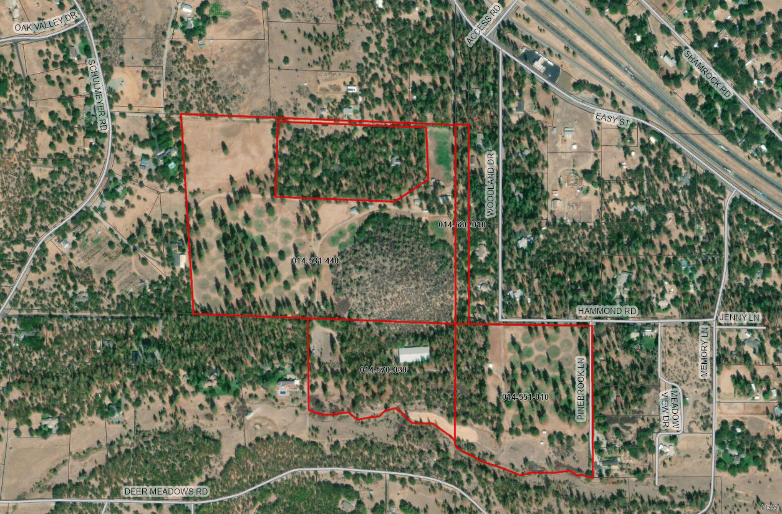   
Figure 1: Subject Parcels

**Agricultural Preserve Administrator Review**

Staff prepared a detailed report (Exhibit B) for review and recommendation by the Agricultural Preserve Administrator. Based on the report, the Administrator found the applicant’s request is not consistent with the County Rules for the Establishment and Administration of Agricultural Preserves and Williamson Act Contracts and recommends the Board direct staff to issue a Notice of Non-Renewal for the 87-acres.

## Environmental Review

Staff recommends the issuance of a notice of non-renewal for the 87-acres of this Williamson Act contract be considered categorically exempt from the California Environmental Quality Act (CEQA) pursuant to CEQA Guidelines Section 15317, *Open Space Easements or Contracts.* A Categorical Exemption implies that the project will not result in any significant adverse environmental effects. The Class 17 exemption applies as this project does not propose to alter or expand the existing Williamson Act contract, which will remain in effect for the nine-year non-renewal period.

The Board of Supervisors must consider the proposed CEQA exemption together with any comments received during the public review process. Further, the exemption can only be approved if the Board finds, based on the whole record before it, that there is not substantial evidence that the project will have a significant effect on the environment. Accordingly, a finding to this effect has been incorporated into the draft resolution prepared for the Board’s consideration.

## Comments

Public Comments

Notice of the project was published and posted as required prior to the Board of Supervisors meeting and no public comment was received as of the preparation of this staff report.

## Recommended Motions

I move to take the following actions:

1. Determine the issuance of a notice of non-renewal is exempt from CEQA in accordance with Section 15317, Open Space Easements or Contracts; and
2. Authorize staff to process the Notice of Non-Renewal with any changes directed by the Board.

Exhibits to the Staff Report

1. Draft Resolution, a Resolution of the County of Siskiyou, State of California, Directing Staff to issue a Notice of Non-Renewal for 87-acres under Contract No. 71036
2. Exhibit A-1 within Draft Resolution: Notice of Non-Renewal – Draft
3. Agricultural Preserve Administrator Staff Report with Recommendation